What’s Happening in Biotech and Pharma Recruitment (And Why More Interesting Than Ever! 🌶️)
3 min listen
0:00
3:18



Bryan Blair

💥LinkedIn Top Voice | Vice President @ GQR
December 20, 2024
Hey everyone! 👋 I’ve been wanting to share some thoughts on the trends I’m seeing in biotech and pharma recruitment lately. You know how it is—when you’re in the thick of it every day, patterns start to emerge, and you just have to talk about them!
The Current Landscape: Why Hiring Is Tougher Than Ever
Let me paint you a picture. 57% of industry leaders are struggling to find the right talent for critical roles. Every day, I feel this firsthand as I work to fill positions in CRISPR, bioinformatics, and cell/gene therapy. The talent pool isn’t just shallow—it sometimes feels like searching for water in a desert!
(Quick story: Just yesterday, a client asked me, "Bryan, where are all the good candidates hiding?" 😅 If only there were a treasure map!)
Here’s the kicker: despite a 12% drop in job postings year-over-year, competition for biotech roles has jumped by 51%. The market is hotter than my attempts at making Thai food (and trust me, my cooking is fiery—but not always in a good way).

Let’s Get Real: The Challenges We’re All Facing
For Hiring Managers:
I get it—the hiring process can feel like it’s moving at the speed of molasses. One client managed to cut their hiring time by 25% using predictive analytics, but that meant overhauling their entire pipeline management system. Change isn’t easy, but it’s necessary to keep up.
For Recruiters:
Can we talk about client expectations for a second? 😮💨 Just last week, someone asked me to find a candidate with 10 years of experience in a technology that’s only existed for 5. (Yes, that really happened!) Plus, technology integration can complicate things—throwing more tools at the problem won’t magically solve it. Lesson learned.
For Job Seekers:
Standing out in this market? Tough. But creativity works. One candidate I placed recently secured their dream role by showcasing a personal side project, which completely overshadowed candidates with more traditional credentials. Take note!

What’s Working: Strategies for Success
For Hiring Managers:
Expand your horizons. I recently placed someone with a project management background into a technical role, and they’re thriving! How? A stellar onboarding process and a willingness to learn made all the difference.
For Recruiters:
Employer branding is a game-changer. Candidates don’t just want jobs—they want to make an impact. One candidate I worked with teared up (in a good way!) during an interview because they connected so deeply with the potential impact of the role on patient lives. That’s the emotional connection we need to foster.
For Job Seekers:
Your LinkedIn profile isn’t working hard enough for you. Highlight measurable achievements—don’t let them stay hidden! And please, join niche forums like Xconomy. The connections you’ll make there are priceless.

Looking Ahead: What’s Next?
The landscape is evolving faster than my coffee gets cold (and trust me, that’s fast). From AI disrupting traditional recruiting to the shifting expectations of today’s workforce, we’re in for a wild ride.
Proactive planning and real-time market insights are critical. Just last week, I helped a client navigate a tricky hiring situation using up-to-date market data. The result? They hired their dream candidate while staying under budget. Wins like that remind me why we do this work.

Let’s Collaborate!
What challenges are you anticipating in 2024? Drop me a line—I’d love to brainstorm solutions with you. The best ideas often come from unexpected conversations. (Fun fact: I once got great recruiting advice from an Uber driver, but that’s a story for another day! 😂)
What’s keeping you up at night when it comes to talent acquisition? Let’s chat!
Cheers,
-Bryan Blair

How to Effectively Sell Job Opportunities in the Era of Workplace Flexibility: A Data-Driven Guide for Hiring Managers
5 min listen
0:00
4:44



Bryan Blair

💥LinkedIn Top Voice | Vice President @ GQR
December 13, 2024

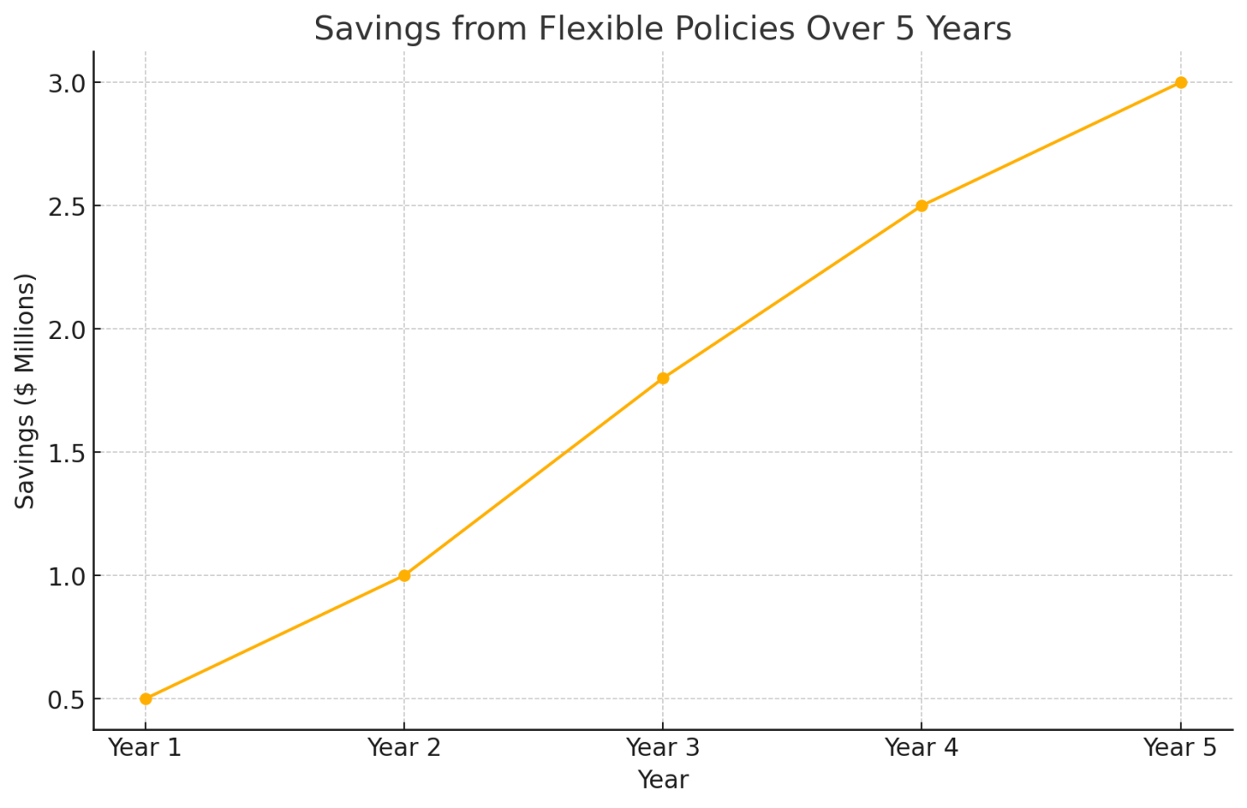
First Tennessee Bank's $3 million savings over five years.
In today’s workplace, hiring managers and talent acquisition professionals face a nuanced challenge: how to attract top-tier talent while juggling return-to-office mandates, hybrid work models, and productivity goals. As flexibility becomes a cornerstone of employee expectations, traditional recruitment strategies often fall short. Rigid workplace policies can alienate high performers, leading to talent loss, stagnated innovation, and declining productivity.
To stay ahead, hiring managers must embrace a data-driven approach—leveraging insights to craft compelling narratives that align with what today’s candidates truly value.

What Top Talent Really Wants
Flexibility has shifted from a “nice-to-have” perk to a non-negotiable for many professionals. Data paints a clear picture of this new reality:
- 75% of employees dissatisfied with workplace flexibility are actively seeking new opportunities.
- Among high performers, dissatisfaction with flexibility results in a 16% drop in intent to stay—double the impact observed among average employees.
Breaking down preferences across demographics reveals even more:

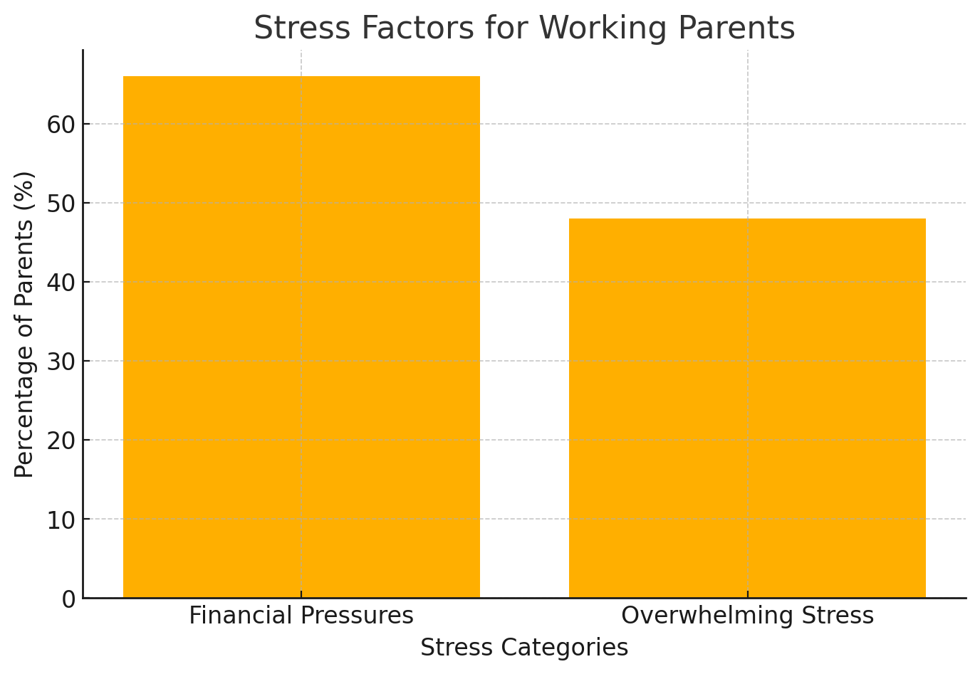
Financial pressures (66%), overwhelming stress (48%).
- Parents: Working mothers (59%) and fathers (47%) overwhelmingly favor remote work three or more days per week to balance professional and personal responsibilities.
- Diverse Professionals: Black, Latino, and Asian American employees prioritize flexibility more than their White counterparts, viewing it as a vital aspect of inclusivity.
- Front-Line Workers: While remote work often takes center stage in discussions, schedule flexibility—like four-day workweeks—remains the top priority for these employees.
These insights highlight flexibility's universal importance in attracting and retaining talent across diverse workforce segments.

The Productivity Paradox: Debunking Myths About Remote Work
One major hurdle to greater flexibility is executive skepticism around productivity. Many leaders worry that remote or hybrid models lead to disengagement, but the evidence strongly contradicts these concerns:
- Only one-third of companies enforcing return-to-office mandates report productivity gains.
- High-trust workplaces double the productivity levels of low-trust environments.
- Employees in high-trust settings are 30% more likely to exert discretionary effort, driving innovation and results.
On the flip side, low-trust environments breed "performative work," where employees spend 32% of their time on unproductive tasks designed to appear busy rather than deliver value.

The Financial and Cultural Costs of Rigid Policies

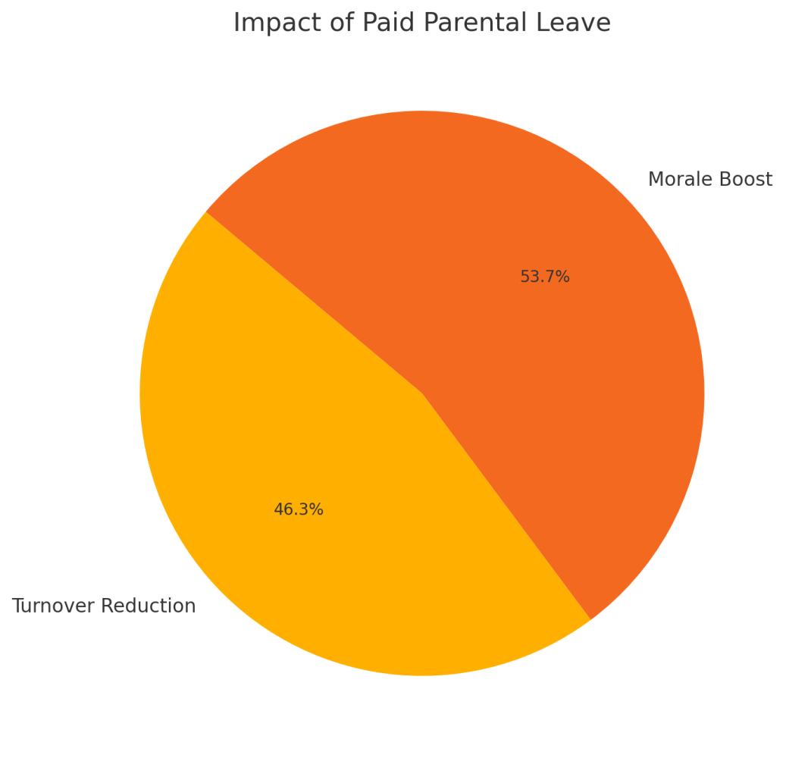
Impact: 69% reduction in turnover, 80% morale boost.
Rigid return-to-office mandates can have unintended consequences. Research from the University of Pittsburgh reveals no significant correlation between such mandates and improved financial outcomes among S&P 500 companies. Instead, rigid policies often hurt organizations in several ways:
- Employee Engagement: Monitoring systems negatively affect 49% of employees, leading to increased stress and declining job satisfaction.
- Retention: High attrition rates among top performers disrupt innovation and continuity.
- Diversity: Companies lose access to talent pools unwilling to sacrifice flexibility.
- Culture: Presenteeism and disengagement erode morale and collaboration.
The data underscores the need for strategic, flexible approaches to maintain a competitive edge.

Strategic Approaches for Selling Opportunities
To attract top candidates, hiring managers must rethink traditional methods and adopt strategies tailored to today’s workforce expectations.
1. Transparency About Work Arrangements
Ambiguity around workplace policies fosters mistrust. Be upfront about your organization’s approach:
- Clearly communicate whether roles are remote, hybrid, or in-office early in the recruitment process.
- Avoid vague language like “flexible work available” without specifics.
- Provide real-world examples, such as sample hybrid schedules or location-independent roles.
2. Focus on Outcomes Over Presence
Trust is the cornerstone of flexible work environments. Demonstrate that your organization values results, not hours spent at a desk:
- Share productivity metrics tied to outcomes rather than activity.
- Highlight success stories of teams thriving in flexible arrangements.
- Showcase trust-based management practices that empower employees.
3. Demonstrate Cultural Alignment
Cultural alignment plays a significant role in candidates’ decision-making. Show your commitment to their success by emphasizing:
- Investments in collaboration tools like Slack or Microsoft Teams.
- Tailored programs for diverse groups, such as mentorship initiatives for underrepresented employees.
- Transparent career advancement pathways, regardless of work location.

Practical Implementation Strategies
Frame the Conversation Around Value
Position your organization as a partner in candidates’ success by focusing on value-driven messaging:
- Share metrics demonstrating team effectiveness in hybrid setups.
- Highlight employee satisfaction rates in flexible roles.
- Provide concrete examples of career growth within your organization’s work model.
Address Concerns Proactively
Candidates often have reservations about remote or hybrid work. Be prepared with data-backed answers to questions such as:
- “How will I grow my career in a hybrid role?”
- “What tools are in place to support remote collaboration?”
Partner with Leadership
Recruitment strategies should align with organizational priorities:
- Share feedback from candidates to inform leadership decisions.
- Regularly update executives on competitor workplace practices.
- Highlight correlations between flexibility and business outcomes.

Emerging Trends Shaping Recruitment
The workplace of the future is already taking shape. Key trends influencing recruitment include:
- Shifting Executive Priorities: Globally, only 4-6% of CEOs prioritize full-time office returns, while 27% of U.S. CEOs view hybrid work as essential for retention.
- Evolving Productivity Metrics: Companies are replacing traditional activity-based measures with outcome-driven KPIs.
- Technological Integration: Advanced collaboration tools and performance monitoring innovations are enabling flexible work models.

Future-Proofing Your Talent Strategy
To remain competitive, hiring managers should focus on these core pillars:
- Develop Clear Narratives: Use storytelling to highlight employee success within your workplace model, emphasizing career growth and achievements.
- Build Robust Frameworks: Implement systems to measure productivity and collaboration effectively.
- Maintain Market Awareness: Regularly assess competitor practices to ensure alignment with evolving workplace trends.
By embracing a data-driven approach, hiring managers can successfully attract top talent while meeting the demands of the modern workforce. The goal isn’t to champion one workplace model over another but to demonstrate how your organization fosters success—for both employees and the business.
-Bryan Blair

The Overlooked Cost of NOT Having a Commute
8 min listen
0:00
8:28



Bryan Blair

💥LinkedIn Top Voice | Vice President @ GQR
October 11, 2024
As someone who has transitioned from working fully remote to commuting into an office three days a week, I can confidently say that it has been one of the best decisions I've ever made. Although I don’t live in the middle of nowhere—I commute into Manhattan, which is notorious for its challenging commutes—I find immense value in going into the office. Yes, it is a major hassle dealing with crowded subways, traffic jams, and the hustle and bustle of the city. However, the benefits far outweigh the inconveniences. I enjoy my job more, feel happier overall, and would even be willing to go in five times a week if it were required of me.
Time Management: The Commute vs. Screen Time
I know what you're thinking: "My life and my situation don't allow for commuting into an office X number of days a week." To that, I say: take a hard look at the screen time on your phone and honestly assess whether you don’t have time in your day for the commute. We often underestimate how much time we spend on activities that don't contribute to our well-being or professional growth. Social media, streaming services, and other digital distractions consume hours of our day that could be better utilized.
While I understand that time spent commuting can be perceived as a waste, it simply requires a shift in mindset. Instead of viewing the commute as lost time, consider it an opportunity for personal and professional development.
Make Your Commute Productive:
- Listen to Industry-Related Audiobooks: Gain new insights and knowledge relevant to your field.
- Podcasts: Explore a wealth of information on virtually any topic imaginable.
- Work-Related Calls: Handle business before even stepping into the office.
- Relaxation: Listen to your favorite music to set a positive tone for the day.
- Mindfulness Apps: Use meditation apps to unwind and reduce stress.
The key is to choose activities that enrich your life rather than detract from it. If you choose not to make effective use of that time, then you will pay the consequences. Time is a finite resource, and how you utilize it directly impacts your personal and professional life.
The Hidden Costs of Digital Distractions
Consider the screen time on your phone spent on platforms like Facebook, Instagram, and Snapchat. We know conclusively that excessive use of these social media apps leads to poorer mental health for their users. If you want to understand this better, please watch "The Social Dilemma" on Netflix. This documentary explores how social media platforms are designed to be addictive and the negative effects they have on mental health. I promise you it's not good for your well-being.
You're better off not making effective use of your commute and stopping the use of social media apps. So, if your argument against commuting is about time constraints, it truly loses its weight when you consider how that time is currently being spent.
Financial Realities: Income Matters More Than You Think
Now, let's discuss income. I'm mindful that money isn't the most important thing for everyone in relation to their career, but working as a recruiter, I can tell you it's a top priority for most people. We can all understand why. We live in a capital-based society where the cost of living continues to rise. Housing, healthcare, education, and daily expenses are constantly increasing, making financial security more important than ever. We all want to enjoy our free time with the financial stability we've hopefully secured from our jobs.
Money and Happiness:
I think it's important we get specific about money and how much is required to live a good life in the United States. The idea that money does not equate to happiness is partially true but not for most people. Financial stress can have a significant impact on mental health and overall quality of life.
- If you earn under $100,000 in income, you should be very concerned about how much money you make because there is a direct correlation between increasing your earnings and the levels of happiness you can expect to achieve.
- Studies have shown that up to a certain point, an increase in income correlates with an increase in happiness and life satisfaction.
- Once you reach the $100,000 mark, that relationship becomes less predictable. The law of diminishing returns comes into play—each additional dollar earned has a smaller impact on happiness.
Still, the more money you make, the happier you can expect to be—just not to the same degree once you're earning over $100,000.
Geographic Considerations:
Most Americans do not earn over $100,000, and if they focused on earning more, they would likely be happier. Financial stability allows for greater freedom, reduced stress, and the ability to pursue passions and interests.
- In New York City, for example, a single person living in Manhattan needs to make $168,000 just to maintain a comfortable quality of life. This accounts for high rent prices, transportation costs, dining, entertainment, and other expenses associated with city living.
- Adjust for Geographic Regions when discussing income levels required for a good life.
The High Cost of Flexibility: Is Remote Work Worth It?
While many workers may enjoy the flexibility of remote work, I want them to understand how high a cost that flexibility comes with. Flexibility might offer short-term comfort, but it's important to consider the long-term implications for your career trajectory and financial well-being.
The Financial Impact:
- Lifetime Earnings: The lifetime earnings of a fully remote employee in 2024 compared to one working in a hybrid capacity are expected to be 38% less over their career according to a recent survey by McKinsey.
- Retirement Savings and Investments: This substantial difference can affect retirement savings, investment opportunities, and overall financial security.
I understand many people don't want to hear this because it's uncomfortable. However, ignoring reality is a recipe for career disaster. Let's at least make informed choices based on facts rather than feelings. Being aware of industry trends and employer preferences can help you make decisions that align with your long-term career goals.
Evidence-Based Facts and Statistics on Remote Workers and Layoffs
Recent data from 2024 highlight a concerning trend for fully remote workers: they are more likely to be laid off compared to their in-office or hybrid counterparts. Here are key statistics:
Higher Layoff Rates for Remote Workers:
- 35% More Likely to Be Laid Off: Fully remote white-collar workers were 35% more likely to be laid off in 2023 compared to colleagues who spent at least some time in the office.
- Promotion Chances Decrease: Remote employees were 31% less likely to get promoted.
Employer Preferences:
- Return to Office: A significant majority of employers are projected to return to physical office locations in 2024.
- Executive Insights: Ninety percent of executives surveyed by Resume Builder indicated a return to in-office work due to productivity and culture enhancement considerations.
Consequences for Non-Compliance:
- Strict Policies: Among 800 U.S. employers surveyed by Resume Builder in December, 95% stated that employees who do not comply with return-to-office mandates will face consequences ranging from reduced bonuses and benefits to pay cuts or termination.
Industry Trends:
- Tech Industry Layoffs: The tech industry has seen significant layoffs in 2024 with companies like Tesla, Amazon, Google, TikTok, Snap, and Microsoft conducting sizable layoffs.
- Shift Towards In-Office Work: While these layoffs aren’t exclusively targeting remote workers, they align with broader industry shifts towards in-office work.
Hybrid Work Policies:
- Lower Layoff Rates: Organizations with hybrid work policies have lower layoff rates compared to those with fully remote policies.
- Statistics: According to The Conference Board, layoffs are less common for organizations with hybrid policies (25%) than fully remote policies (33%).
The Career Risks of Full-Time Remote Work
Recent studies reveal potential drawbacks of choosing full-time remote work out of personal preference concerning career advancement and earning potential:
Layoff and Promotion Risks:
- Higher Layoff Probability: Fully remote white-collar workers are 35% more likely to be laid off.
- Reduced Promotion Opportunities: They are 31% less likely to get promoted compared to their in-office or hybrid counterparts.
Bonus Disparities:
- Less Likely to Receive Bonuses: Remote workers are 38% less likely to receive bonuses compared to their in-office peers.
Performance Reviews:
- Managerial Biases: Remote workers tend to have worse performance reviews due partly to managerial biases favoring employees seen in the office daily.
Earning Potential:
- Hybrid Workers Earn More: Hybrid workers earn more than both fully remote and in-office workers—specifically 23.4% more than fully remote workers and 12% more than in-office workers.
Promotion Opportunities:
- Employer Strategies: A survey by The Conference Board found that 10% of Chief Human Resource Officers plan to increase promotion eligibility for fully in-office workers compared to fully remote ones.
Development Opportunities:
- In-Office Advantages: In-office employees are more likely to receive development opportunities; 7% of CHROs plan to increase these opportunities for them compared to fully remote workers.
Employer Preferences:
- Strong Preference for In-Office Work: A strong preference exists among employers for in-office work; 95% of surveyed employers indicated that employees who do not comply with return-to-office mandates will face consequences.
Make Informed Decisions for Your Career
The best thing you can do for your career is understand the consequences of your actions and make informed decisions. While remote work offers convenience and flexibility, it's essential to consider its long-term impacts on career progression, job security, and earning potential. By staying informed about industry trends and employer expectations, you can make choices that align with your professional goals.
Closing Thoughts: Weigh the Benefits Against the Costs
In conclusion, commuting into the office—even if just a few days a week—can provide significant advantages. It enhances visibility, opens up opportunities for advancement, and aligns with many employers' preferences.
Before deciding on full-time remote work, weigh potential drawbacks against benefits. Consider how you can maximize commute time and how increased earnings and job security can enhance your overall happiness and quality of life. Make choices based on evidence and data to ensure a fulfilling and successful career.
-Bryan

What's your take on the remote vs. in-office debate? Feel free to share your thoughts and experiences in the comments below.

Managing Multiple Requisitions: Strategies for Success
5 min listen
0:00
4:42



Bryan Blair

💥LinkedIn Top Voice | Vice President @ GQR
August 30, 2024

A comprehensive guide to help recruiters effectively handle a high volume of open requisitions. Discover strategies for prioritizing efforts, utilizing time blocking, aligning with hiring managers, and leveraging external agencies to optimize recruiting outcomes.

Managing Multiple Requisitions: Strategies for Success
Feeling overwhelmed by a mountain of open requisitions? Discover the best strategies to prioritize critical roles, leverage time-blocking, and align with hiring managers for recruiting success.
As a recruiter, you're no stranger to the overwhelming feeling that comes with managing a high volume of open requisitions. It's a constant juggling act, trying to give each hiring manager and candidate the attention they deserve while also sourcing and screening for new roles that crop up daily.
According to a 2021 survey by LinkedIn, 61% of recruiters report that their job is more stressful now than a year ago, with managing multiple requisitions being a significant contributor. Every recruiter I've talked to totally gets that feeling of being swamped by the endless number of requisitions. But here's the good news: with the right strategies in place, you can masterfully manage your requisition load and deliver exceptional results.

1. Prioritize Recruiting Efforts Based on Business Impact
When everything feels urgent, it's easy to fall into reactive mode. To manage a high requisition load effectively, you must proactively prioritize roles based on their business impact.
Start by assessing your open roles:
- Which positions are most essential for your company’s success?
- Which teams are feeling the most pain due to vacancies?
A study by McKinsey found that high-performers are 400% more productive than average ones in complex occupations and 800% more productive in highly complex jobs. This underscores the importance of prioritizing critical roles that significantly impact your company's performance.
Key Questions to Consider:
- Which roles are critical for hitting our quarterly goals and KPIs?
- Which teams are blocking key projects due to lack of headcount?
- Which positions, if filled, will free up the most additional capacity on teams?
- Which searches are for leadership or executive roles that will have a multiplying effect?

2. Master Your Weekly Schedule with Time Blocking
Time blocking means dividing your day into "blocks" dedicated to specific tasks. By proactively planning your week, you can ensure time for top priorities while leaving room for inevitable ad hoc tasks.
Sample Weekly Schedule:
- Monday AM: Prioritization, responding to emails/requests
- Monday PM: Sourcing for top priority roles
- Tuesday AM: Screening calls with prioritized candidates
- Tuesday PM: Preparing candidates and hiring managers for interviews
- Wednesday: Interviews for top-priority roles
- Thursday AM: Follow-ups and interview feedback
- Thursday PM: Sourcing for secondary priority roles
- Friday AM: Pipeline review and status updates
- Friday PM: Hiring manager check-ins, prepping for the following week
Additional Tips:
- Create your time blocks in your calendar to avoid conflicts.
- Set aside blocks for communication (email/Slack) to prevent constant interruptions.
- Leave some "flex" time each day for unexpected issues.
- Regularly assess and adjust your schedule as needed.

3. Align Early and Often with Hiring Managers
The relationship with your hiring managers is vital to recruiting success. Strong alignment reduces time-to-fill and improves the quality of hire, as shown by a study from Bersin by Deloitte, which found organizations with strong recruiter-manager partnerships are 3x more likely to reduce time-to-fill.
Key Steps for Alignment:
- Involve hiring managers early in the process—calibrate on must-have skills and review sample resumes.
- Debrief after interviews to gather feedback and reassess alignment.
- Set expectations upfront about the intake and feedback process.
By investing in strong hiring manager relationships, you reduce miscommunication and ensure faster, more efficient hiring processes.

4. Calibrate Constantly to Avoid Wasted Efforts
Misalignment can creep in over time, leading to wasted effort. Regularly check in with hiring managers to ensure you're on the same page.
Tactics for Calibration:
- Regularly review job descriptions to ensure they reflect current requirements.
- Hold post-interview sessions to align on feedback and next steps.
- Monitor pipeline metrics to spot signs of misalignment (e.g., high rejection rates).
By maintaining regular calibration, you’ll reduce miscommunication and wasted time while improving the quality of candidates moving through the process.

5. Leverage External Agencies for Strategic Support
External recruitment agencies can help alleviate pressure by providing access to a broader talent pool, specialized expertise, and the flexibility to scale efforts during peak hiring periods.
Advantages of External Agencies:
- Access to a wider talent pool: Agencies often have access to passive job seekers.
- Specialized expertise: Agencies bring deep market knowledge and industry-specific insights.
- Scalability: Quickly scale up recruiting efforts without additional internal resources.
Collaborating with external agencies can reduce time-to-fill and improve efficiency during high-volume hiring.

6. Use Requisition Management and Scheduling Tools
The right tools make staying on top of your requisitions much easier. Utilize your ATS, Recruiting CRM, or platforms like Trello, Asana, or Airtable to track key metrics and milestones.
Key Features to Maximize:
- Dashboards for all open roles
- Candidate pipelines tracking each applicant’s stage
- Scheduling tools for interviews and follow-ups
- Reporting tools for key metrics (e.g., time-to-fill, offer acceptance rates)
Keeping your system updated and centralized helps ensure smooth coordination and maximizes efficiency.

7. Conduct Daily Pipeline Health Checks
Set aside time each day for a quick review of the pipeline’s health. Focus on:
- Candidate stages: Are enough candidates progressing?
- Feedback: Has feedback been gathered promptly?
- Action items: What’s next for each open role?
By consistently conducting pipeline health checks, you can proactively address bottlenecks and keep everything moving smoothly.

In Summary Managing multiple requisitions doesn’t have to be overwhelming. With strategic prioritization, time blocking, strong alignment with hiring managers, and the right tools, you can effectively manage your workload and deliver excellent results.
- Bryan

